Sincu u hosted noow poer and all 7860 inncode,
to run locally u have to chsnge it to 8000 as local react runs in 8000 port and fastapi end is 3000

To run in terminal inside front end folder
///inside app directory only working
npm run dev
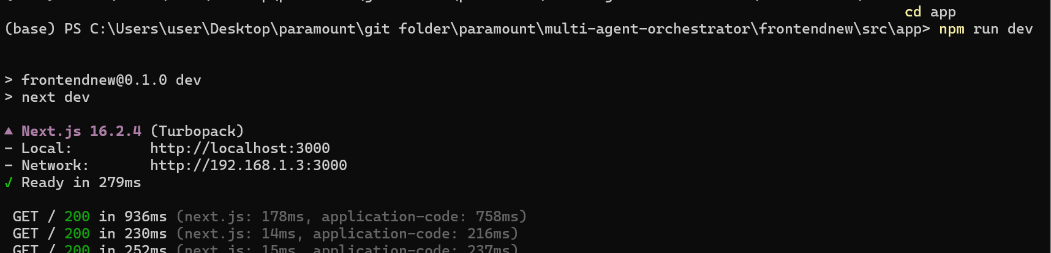
For backend another terminal
Cd backend
.\venv\Scripts\activate
uvicorn main:app –reload (or) uvicorn main:app --reload --port 8000

